**Agents**

1. Bug Analysis
2. Bug Resolution Suggestion

**Code**

**https://github.com/Suchi-BITS/PM/blob/main/Codes/ProjMan/automated_bug_analysis.py**

**Workflow and UI**  
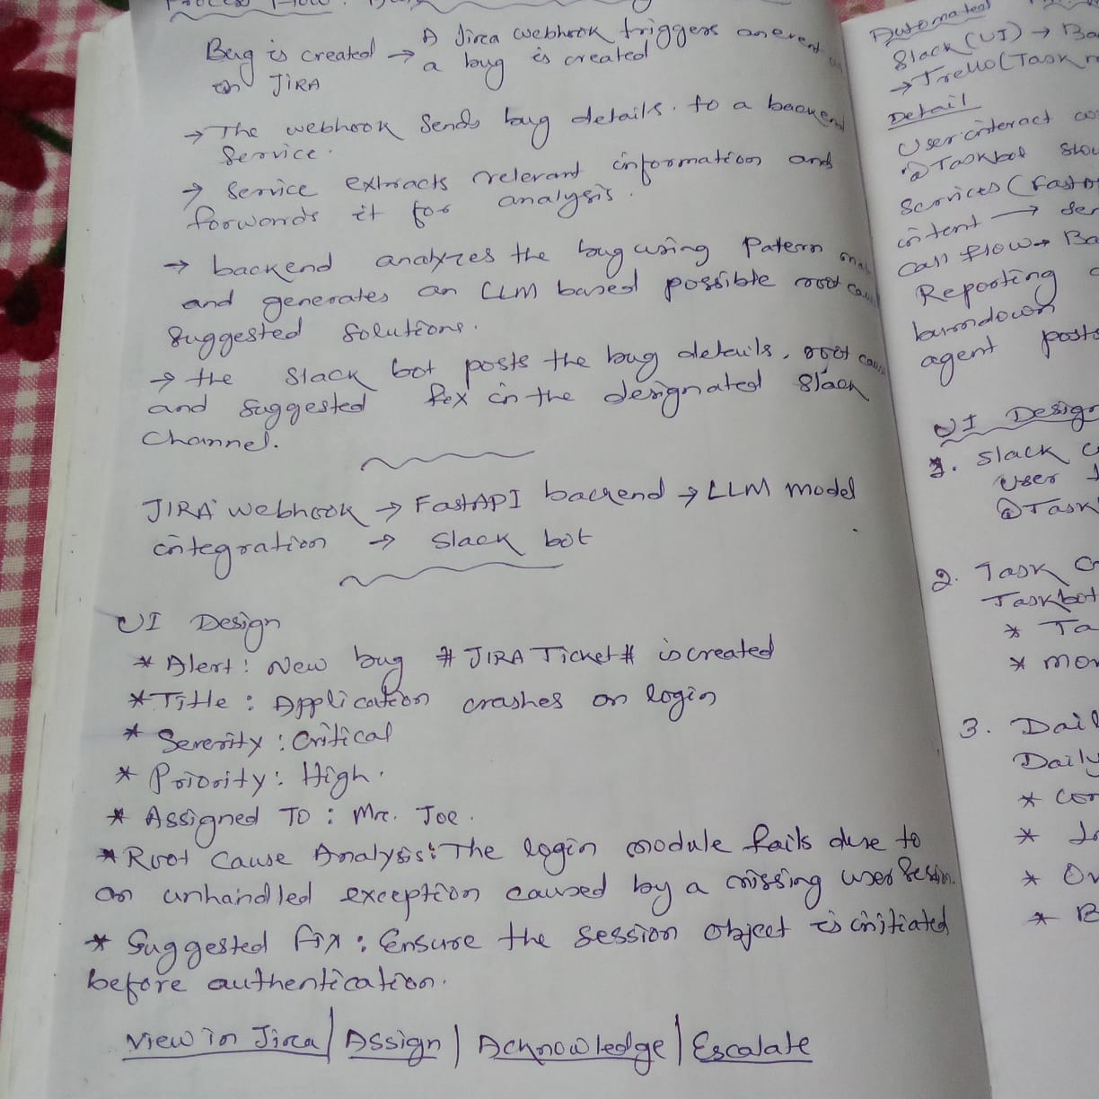

## **Setting up AI agents in Slack**

Here's a step-by-step guide to creating your own AI agent in Slack:

### 1. Create your app

* Navigate to "Your Apps" in Slack
* Click "Create New App" and select "From scratch"
* Name your app and select your development workspace
* Click "Create App"

‍2. Configure the Assistant View

* Find the "App Assistant View" section in the left navigation
* Enable the new container
* Add an overview that will appear in the container
* Choose between fixed or dynamic prompts
* Save your settings

‍3. Set up Socket Mode

* Enable Socket Mode for testing purposes (Note: This isn't recommended for production environments)
* Generate an app-level token when prompted
* Ensure the connections:write scope is added
* Save your generated token for later use

‍4. Configure permissions

* Go to "OAuth & Permissions"
* Verify that assistant:write scope is automatically added
* Add additional required scopes:some text
  + im:history
  + chat:write

‍5. Set up event subscriptions

* Enable Events in the Event Subscriptions section
* Subscribe to necessary bot events:some text
  + assistant_thread_started
  + assistant_thread_context_changed
  + message.im
* Save your changes

‍6. Install and test

* Navigate to the Install App section
* Click "Install to Workspace"
* Grant necessary permissions
* Save the bot token provided after installation
* Check your Slack client to verify the app appears